Cloud and Social Network Security (work plan)

I suggest to elaborate on the following text in order to make a comprehensive paper on cloud security mechanisms.
- Thiago and I will determine what are the typical user activities in the system (they are mentioned below, it is just necessary to describe scenarios more elaborately).
- From this it will be possible to determine the possible sets of metrics.
- I can send the necessary metrics to be collected from the log files of the cloud system.
- Thiago can develop a model application in Java, that can work with the real-time collected log information.
- If all goes well, such article can be finished in a month and the tool can be applied in our cloud system, which is named Storgrid.
- This paper can be elaborated more if we can add some EKE (encrypted key exchange) protocol to the whole system. I have a student that works on such a system. This can be a second paper.
- Another direction that I suggest – is the detection of malicious activity in the social networks. It is known that the criminals and terrorists organize their actions through social networks. In the branch of our department we develop a social network search engine. It is possible to combine this search engine, select the metrics necessary for analysis, and apply the MOS method to distinguish the criminal groups and activities.

(this is the core of the paper that is published next month in a journal in Belarus)

The client workflow
The additional alarm protection system based on the signal processing techniques is correlated with the client workflow. Below we describe the typical activities of the client. The most important feature of the client-side encryption is the uniqueness and unchangeability of the session key to access the separate shares (files) which allows accessing a share in the off-line mode. But, this feature can compromise security. To address this problem, we provide session key encryption by means of the modified ABE with the key expiration period. Thus, we implement a hybrid encryption system:

• File encryption: A unique symmetric key is generated for each file. Then, the file is encrypted with AES-128 using this unique key. The resulting encrypted file is sent to the client (e.g.: Iphone, Ipad or Android device). The AES key is encrypted with the modified ABE with respect to the file sharing participants list and sent to the client to be stored locally.
• File decryption: The client checks if the private key of a user is still valid. If so, the file key is decrypted with his appropriate ABE key. If the file key is decrypted successfully then the file is decrypted with AES-128. ABE serves to preserve the access control policy and does not allow the access to the files by unauthorized users.
The typical actions of the user are as follows:

1. The user starts-up the cloud storage client application, enters the PIN code and opens the domain, i.e., the interaction with the protected cloud. Meanwhile, the login procedure receives the actual user ABE private key.
2. The user selects the files for synchronization with the server. This means that encrypted files are saved to the user device storage. A user can see them in his file browser, but these files are encrypted and cannot be used directly.
3. The user clicks via the context menu/button “Decrypt”. The file is then decrypted, and directly opened with the application that is associated with the appropriate extension. This is possible since in the background the application checks the private key validity, decrypts the file and saves the non-encrypted file in the local file system.
4. The user modifies the decrypted files and saves them locally. When a file is modified it will be uploaded to the server and will be encrypted again. It is the responsibility of the user to save the file back to the globally controlled cloud storage and not to save it anywhere else. When the user saves the file, it is sent to the encryption server and hence encrypted.
5. The user synchronizes with the global storage in order to save the modifications if allowed.
The Figure 2 demonstrates the UI of the protected cloud storage.
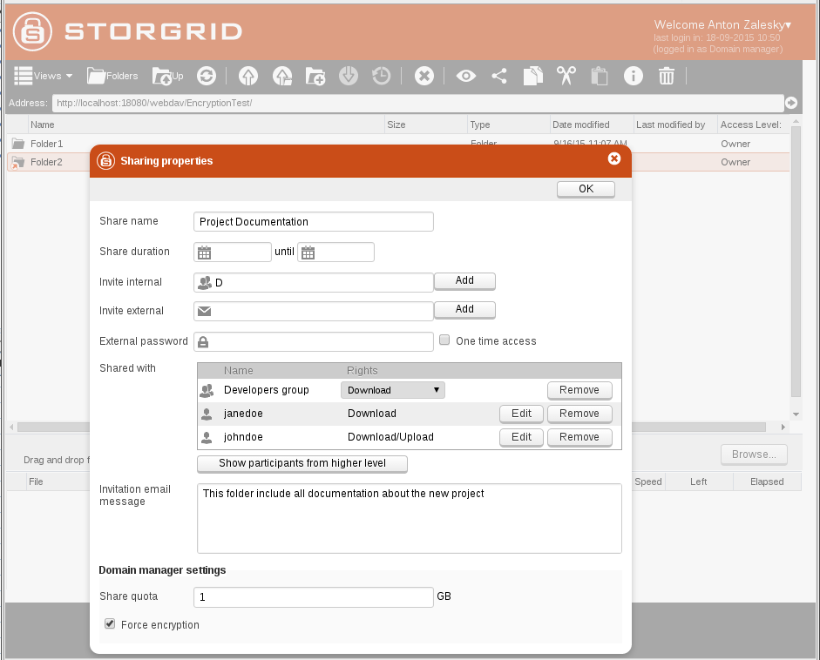
Figure 2: Protected storage UI

Analysis of attack scenarios
Regarding the private keys of the ABE encryption, they are protected by the following mechanisms: centralized generation, uniqueness, and expiration/revocation. Therefore, the attacker cannot do much even if he steals the whole set of keys. He needs to gain access to the device itself, and then is able to explore this access only within the key expiration period. The attacker cannot substitute these keys as performed in the classical MITC attack [2].
The most insecure scenario for the proposed system is when the attacker steals the permanent user credentials, namely, password and login. He can do it by means of social engineering, for example. In order to protect the user from this threat we propose to use such cautionary methods as hashing/secret sharing or PBE/ PAKE protocols [6], which can be integrated to our proposal.
Also, to increase the security we propose an attack detection system, which allows to quickly discovering the malicious activity based on the user actions analysis. This system functionality is based on the typical behavior of the attacker after stealing an authorized user credentials:

• Downloading user files randomly;
• Modifying and uploading files randomly or massively;
• Repeatedly downloading the files that are already on the device.

All these types of activities can be detected with signal processing techniques. We propose to analyze the following info:

• Number of files uploaded/downloaded;
• Time delay between downloading the files (if it is too short – this indicates a bot action, not a real user one);
• Number of files re-downloaded/uploaded – normally the user keeps the files on his device and doesn’t need to refresh it for some time.

We propose to extract the info from the log in the following form:

• Apply feature selection techniques to identify valuable features;
• Using Model Order Selection schemes for abnormalities detection;
• Enriching the attack detection through techniques for obtaining detailed information about attacks.

The log analysis algorithm
Most of the attacks incurs into significant variation (anomaly) from the standard behavior of information systems or present well-known signatures that can be easily detected by a monitoring system. Intrusion detection and intrusion prevention systems are security systems used respectively to detect (passively) and prevent (proactively) threats to computer systems and computer networks. Given the cited attack characteristics, such systems can work in the following modes: signature-based, anomaly-based or hybrid [7, 8].
Signal processing techniques have been successfully applied to network anomaly detection [3,4] and have been a research problem whose solutions are important in order to achieve improvements in detection accuracy and reducing the computational cost of detection.
In the context of anomaly-based schemes, in this paper the proposed log analysis algorithm applies signal processing techniques, such as Principal Component Analyis and Model Order Selection schemes, for automatic identification of attacks or malicious behaviors. Additionally, other techniques can be used to obtain detailed information about the malicious behavior, making possible to identify patterns and obtain the necessary information for performing reactive and proactive actions against the attacks and possible threats.
Therefore, the desired information for detection purposes is extracted from the collected log, in order to obtain useful features that shall be modeled as matrices that represent a signal superposition containing noise, legitimate and malicious traffic. The table shows the example of the collected log information:

Information extracted from the cloud storage log utility

User login | Average | Min | Max | KB/sec | Avg. Bytes
5 shares available | 982 | 225 | 1990 | 146.36 | 7459
10 shares available | 1140 | 340 | 4176 | 223.88 | 13218
25 shares available | 1267 | 887 | 2303 | 294.55 | 19466

From the extracted features the behavioral evaluation shall be performed for identification of anomalies over time, such as outstanding anomalies or less expressive variations on the observed behavior. For this analysis we adopt the eigenvalue analysis based on covariance and correlation, thus highlighting behavior changing that shall be used as input for attack detection through Model Order Selection schemes.
The selected Model Order Selection scheme detects the attack occurrences, and needs to be complemented by techniques to extract detailed information of detected attacks. For detailed information extraction and attack identification we apply eigen analysis and similarity analysis for obtaining detailed information about the accurate attack time and the attacker identification.

